**Display More Than 3 Views in SharePoint 2013**

1.  Go to the list or library where you want to see additional views.

2.  In the upper right corner of the page, click the cog and select **Edit Page**.

[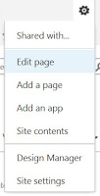](http://4.bp.blogspot.com/-vzQn9ObI3_s/VbkArjoQNrI/AAAAAAAAC0g/mLP5FGU0VNw/s1600/Edit_Page.jpg)

3.  Click **Add a Web Part** in the main window area.

[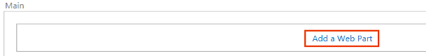](http://3.bp.blogspot.com/-rEa--RXv7Tc/VbvdYp7jM0I/AAAAAAAAC14/FR509OlA4x4/s1600/Add_A_Web_Part.png)

4.  In the webpart **Categories**, scroll down and select **Media and Content**. Select**Script Editor** and click **Add**.

[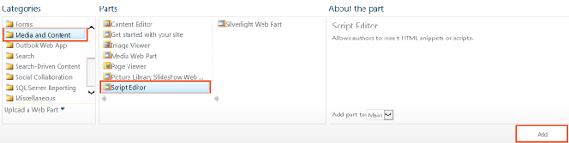](http://2.bp.blogspot.com/-TrFPxCvSgrc/Vbvd_c4aZkI/AAAAAAAAC2A/DfR7GphxW_c/s1600/Add_Script_Editor.png)

5. In the **Script Editor**, click**Edit Snippet**.

[http://3.bp.blogspot.com/-xf_MhwKsTts/VbveFN4e1AI/AAAAAAAAC2I/-8hjBvqD0PI/s1600/Edit_Snippet.png](http://3.bp.blogspot.com/-xf_MhwKsTts/VbveFN4e1AI/AAAAAAAAC2I/-8hjBvqD0PI/s1600/Edit_Snippet.png)

6. In the **Embed**window, paste this code.

<script type="text/javascript">

ExecuteOrDelayUntilScriptLoaded(overrideSurfacePivotCount, 'clienttemplates.js');

function overrideSurfacePivotCount() {

ClientPivotControl.prototype.SurfacedPivotCount = 6;

};

</script>

7.  The "6" in the script above determines how many view selections to show. Change this number as needed. Click **Insert** on the **Embed** window.

[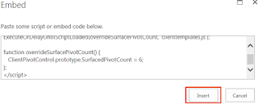](http://1.bp.blogspot.com/-DJE8JL9Sj3o/VbveUOBtbbI/AAAAAAAAC2Q/j_-U64aTT2g/s1600/Embed_Window.png)

8.  Click **Stop Editing** in the upper left of the SharePoint ribbon.

[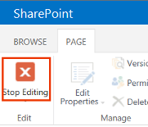](http://4.bp.blogspot.com/-GtRcqTGDBzA/Vbvexa8VM1I/AAAAAAAAC2Y/QggDyt-XBZA/s1600/Stop_Editing_Page.png)

9.  Test the views.

